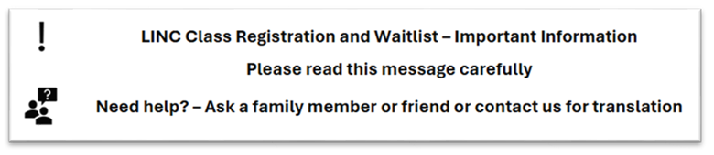
[Translation of the above if needed]

Hi LINC (…Level…) Waitlisted Client,

We are emailing you because you are on the [SPO] LINC Program waitlist for:

Level: (client’s Level)

City:

There are classes available now at your level in Surrey with other LINC schools.

Please see below a list of schools who have classes open at your level:


Organization | Address | Phone Number | Email

If you want to join one of these classes, please contact the school by email, phone, or go to the address mentioned in the chart.

If you have any questions, please email:

[email address]

We hope this information helps you.
All the best,
[SPO] Registration Team

